The Effect of Online Lectures and Online Discussion Participation on Learning Effectiveness of Office Administration Education Students at Jakarta State University

Wiwit Aulia¹, Christian Wiradendi Wolor², Darma Rika Swaramarinda³

¹Department of Office Administration Education, Universitas Negeri Jakarta, Indonesia
²Department of Office Administration Education, Universitas Negeri Jakarta, Indonesia
³Department of Office Administration Education, Universitas Negeri Jakarta, Indonesia.

Abstract
This research aims to determine the effect of Online Lectures and Online Discussion Participation on Learning Effectiveness of Office Administration Education (PAP) Students, Faculty of Economics & Business (FEB) at Jakarta State University (UNJ). The research method uses a quantitative approach with a survey method. The data obtained is primary data through a survey by distributing questionnaires online using Google Forms with a purposive random sampling technique. The population in this study were 172 active students of the office administration PAP UNJ class of 2022 and 2023 with a total of 119 samples calculated based on the Slovin formula. The data analysis technique uses IBM SPSS Statistics 26 software to test and determine the relationship between hypotheses. The results of this research are that there is a positive and significant influence between Online Lectures (X1) and Online Discussion Participation (X2) on Learning Effectiveness (Y) of Office Administration Education students at the Faculty of Economics & Business, Jakarta State University.

Keyword: Online Lectures; Online Discussion Participation; Learning Effectiveness

1. Introduction
Online lectures in Indonesia have experienced a significant acceleration of adaptation due to the COVID-19 pandemic. Although it has been regulated in regulations, its massive implementation only occurred during the pandemic. The Office Administration Education Study Program of FEB UNJ is one example that implemented online lectures as a solution to social restrictions. Online education, despite the conclusion of the pandemic, continues to thrive in a blended modality that integrates virtual (online) and in-person (face to face) learning methodologies. This evolution demonstrates that digital learning environments have become an essential component within Indonesia's tertiary education infrastructure.
Online lectures are learning that utilizes technology to enable interaction between lecturers and students remotely. In the context of this research, Online Lectures in Office Administration Education Jakarta State University Study Program are applied as a solution to the limitations of classrooms and as a form of learning flexibility. Lecture materials are generally presented in the form of files, videos, or texts that students can access through virtual (online) learning platforms. The implementation of online learning constitutes an educational delivery system conducted without physical presence while still effectively supporting teaching and learning activities. (Sofyana & Abdul, 2019). This approach allows students to learn anytime and anywhere, and provides flexibility in managing study time.
Participation in online discussions or students' involvement in exchanging ideas, asking questions, When students respond to others' ideas through digital learning platforms, they demonstrate both their grasp of the material and their ability to analyze information thoughtfully, communicate, and collaborate. A high level of discussion participation signifies learning effectiveness (Ertmer & Koehler, 2015). By actively participating, students not only receive information, but also actively construct their own knowledge. Participation in online discussions has become an essential element in modern education, which focuses on developing advanced thinking abilities and interpersonal competencies.
Learning effectiveness represents a measurement of of how successful a learning method has been. The active involvement of students is important in achieving learning objectives. Multiple determinants impact educational efficacy, including learner attributes, instructional content quality, and resource accessibility, and pedagogical abilities of educators. These key elements work together to shape the overall learning experience and outcomes, influence each other and contribute to the success of learning. Effective learning is a dynamic process and involves complex interactions between various components. Learning is not just a transfer of information, but also a process of knowledge construction that is actively carried out by students (Hidayah et. al., 2020), and (Rahmawati, 2015).
Research findings present a nuanced perspective, indicating that while some studies suggest online education and discussion participation have minimal impact on learning effectiveness, other empirical evidence demonstrates that active engagement in virtual (online) discussions correlates positively with enhanced learning outcomes. This research indicates that online (digital) learning extends beyond serving as an alternative option, establishing itself as a potentially effective and efficient methodology within the educational process. (Khusniyah et. al., 2019), (Nguyen, T., 2015), (Alzahrani, G. M., 2017), (Guiller et. al., 2008), (Bao, 2020), and (Dixson, 2015).
Divergent findings suggest that online (digital) learning and online (virtual) participation metrics demonstrate negligible influence on instructional efficacy, and in certain contexts may precipitate cognitive saturation, potentially yielding inferior educational outcomes compared to traditional in-person (face to face) pedagogical approaches. (Rahman et. al., 2023), (Nurjannah et. al., 2023), (Parsad & Lewis, 2008), (Means et. al., 2009), (Kirschner et. al., 2006), and (Maki et. al., 2000).
To provide an initial overview of the topic to be studied, a preliminary survey of 20 Office Administration Education students at Jakarta State University revealed mixed perceptions about online learning by asking 6 questions. The results were 40% felt it was easier to concentrate during online lectures compared to face-to-face lectures, 50% felt online lectures were as effective as face-to-face lectures in achieving learning objectives, 50% felt online lectures were effective in developing their various soft skills such as communication, collaboration, and time management, 65% felt online lectures provided time flexibility that could increase their learning effectiveness, 45% felt that interactions in online discussions were of the same quality as face-to-face discussions, 60% felt more comfortable expressing opinions in online discussions than face-to-face.
Based on the background and temporary surveys conducted, gap research was found which showed different research results related to whether or not there was an effect of Online Lectures and Online Discussion Participation Levels on Learning Effectiveness, because of this the researcher was interested in conducting research on the Effect of Online Lectures and Online Discussion Participation Levels on Learning Effectiveness in Office Administration Education students at State University Jakarta.
2. Literature Review
2.1 Online Lecturers
Online lectures represent a learning system that primarily uses the internet for delivery. In this approach, educational materials come in different formats like modules, videos, audio recordings, and written content prepared by university lecturers or academic staff. Online lectures enable students and instructors to interact and learn together through internet technology, without requiring physical presence in the same location. This system allows educational activities to continue effectively despite geographical separation between participants (Handarini, 2020). The main goal of online learning is to expand educational opportunities, making learning accessible to a broader and more diverse audience beyond traditional classroom settings (Sofyana & Abdul, 2019).
There are several indicators of Online Lectures, according to Rusman (2011), namely (1) Independence, this can be seen from the aspect of the availability of time to learn. This can be seen from the aspects of the availability of time, place, teachers and learning resources. Online learning certainly causes more student-centered learning. (2) Accessibility, Learning resources and teaching and learning activities should be easy to access for both students and teachers. (3) Interactivity, Online Lectures must have characteristics that can be seen from the availability of communication channels both directly and indirectly. (4) Enrichment, teachers do not only provide distance learning, but teachers also provide assignments or questions in each competency to be achieved to measure the extent to which students understand online learning materials.

2.2 Online Discussion Participation
Online discussion participation means how actively students engage in discussions through internet platforms. This participation is crucial for effective learning. When students actively participate, they can better achieve their learning goals and improve their academic performance (Mislinawati, 2020). Student activeness serves as a key indicator that significantly influences learning effectiveness. In fact, student activeness is the most essential component of teaching and learning activities (Sinar, 2018). This is because a student's level of active participation can directly impact both their knowledge acquisition and the final grades they receive. Supporting this idea, Indrijati (2017) points out that the learning process must involve students being active in building their own knowledge. Students need to engage actively rather than passively receiving information in order to truly develop understanding.
There are several indicators of Online Discussion Participation according to Ginanjar, Darmawan, & Sriyono (2019), (1) Students Ability (2) Students Courage (3) Students Optimism to Express Their Opinions (4) Level of Collaboration With Other Participants.
2.3 Learning Effectiveness
The effectiveness of learning is about transforming something that was "difficult to learn" into something that is "easy to learn." It measures how successful the interaction process is in educational settings when trying to achieve learning goals (Hidayah, Adawiyah, & Mahanani, 2020). Learning effectiveness measures how well students interact with each other and with teachers in educational situations to accomplish learning objectives (Rohmawati, 2015). We can see learning effectiveness by looking at three things: how active students are during learning, how students respond to the learning experience, and how well students master the concepts being taught. In essence, learning effectiveness serves as a way to measure the success of learning interactions whether these occur between students themselves or between students and their teachers in achieving the intended educational goals (Yolandasari, 2020).
There are several indicators of Learning Effectiveness according to Wahyuddin & Nurcahaya (2019), (1) student learning outcomes, (2) student activities in the learning process, (3) learning implementation, and (4) student responses to the learning process. Herawati, Retnowati, & Harijanto (2021) indicators of learning effectiveness, namely: 1) success of learning activities, (2) success in managing learning, (3) success of communication in learning, (4) successful preparation of subject matter, (5) success in implementing learning, (6) success in measuring learning outcomes. Nurpuspitasari et. al. (2019) also explained the indicators of learning effectiveness including, (1) Application of learning models in class, (2) Use of learning media in class, (3) Class management, (4) Teaching evaluation, and (5) Interaction between teachers and students.
It can be synthesized that learning effectiveness is a measure of success in the teaching and learning process characterized by positive changes in student abilities. This process involves interaction between students and students and students and teachers in a learning environment that aims to achieve predetermined learning targets. The indicators are student learning outcomes, student responses to the learning process, the success of learning activities, student activities in the learning process, and the interaction between teachers and students.

3. Material and Method
3.1 Design Study
This research was conducted on students at Universitas Negeri Jakarta, which is located at Jalan Rawa Mangun Muka Raya No.11, RT.11 / RW.14, Kel. Rawamangun, Kec. Pulo Gadung, East Jakarta City, 13220. This research uses quantitative research methods by collecting data through questionnaires and providing questions and statements to respondents online via Goggle Form. The existence of this study is intended to determine the effect of Online Lectures (X1) and Online Discussion Participation (X2) on Learning Effectiveness (Y). The data analysis method used in this research is IBM SPSS Statistics 26. The population in this study were students from PAP FEB UNJ Class of 2022 & 2023 with totaling 172 students. Determination and calculation of the sample using the Slovin formula where the sample to be used is 119 out of 172 students. The technique used in sampling uses a purposive sampling model consisting of certain individuals who meet the criteria determined by the researcher. In this study, researchers took samples that had the following criteria:
- Active students of PAP study program, Faculty of Economics & Business, State University of Jakarta class of 2022 & 2023.
- Experience online lectures directiy.
3.2 Data Analysis
The analysis technique used in this research is multiple regression analysis technique. Regression is one of the analytical methods used to see the influence between two or more variables. In this study, the use of regression techniques was carried out to determine whether or not there was an influence between learning styles and interest in learning on learning outcomes.
The data management technique used in this research is to use the IBM SPSS Statistics version 26 program. SPSS stands for Statistical Package for Social Scient, which is an application used to calculate or analyze advanced statistics. In this research, IBM SPSS Statistics was used to process data in the form of basic assumption tests and hypothesis testing.
Researchers use primary and secondary data with primary data collection in the form of a questionnaire containing several questions and statements related to the topic under study to respondents online via Google Forms. Then the variable measurement uses the variable indicators that have been described as benchmarks for compiling questions or statements. Researchers use a Likert scale to measure answers, opinions, and perceptions of individuals regarding the topic under study using a scale of 1 to 5, where 1 = Strongly Disagree, 2 = Disagree 3 = Undecided, 4 = Agree, 5 = Strongly Agree.
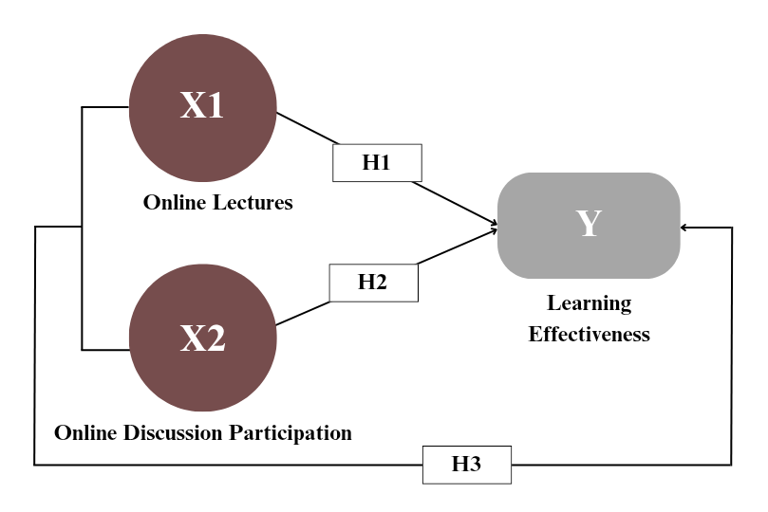

Figure 1. Research Model
4. Result
The following data illustrates the results regarding the distribution or pattern of data distribution used in the study. This study involves three variables including two independent variables, namely Online Lectures (X1) and Online Discussion Participation (X2) and one dependent variable, namely Learning Effectiveness (Y).
Table 1. Simultaneous Regression Coefficient Test (F Test)
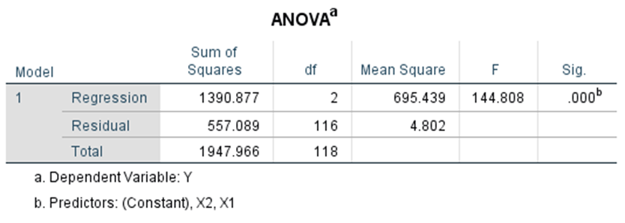
The F-test is a statistical tool that helps us evaluate if a regression model is meaningful overall. It examines whether the independent variables (predictors) collectively have any real impact on what we're trying to predict (the dependent variable). In simpler terms, it tells us if our regression model is actually useful in explaining the relationships we're studying, or if we might as well not use these variables at all.The following data illustrates the results regardingJas

The F-table value is based on a significance level of 0.05, df 1 (number of independent and dependent variables - 1) or 3-1 = 1 and df 2 = n-k-1 = 119-2-1 = 116. Because of the value of Sig. 0.000 <0.05, it can be conclude that there is a significant influence of Online Lectures and Online Discussion Participation together on the Learning Effectiveness of Office Administration Education students at Jakarta State University.
Table 2. Parameter Regression Coefficient Test (t test)
A T-test in regression analysis helps determine if there's a meaningful relationship between two variables. Specifically, it tells us whether changes in one variable (the independent variable) are truly associated with changes in another variable (the dependent variable), or if any observed relationship might just be due to chance. The test produces a statistical value that helps researchers decide if the independent variable has a real, significant impact on the dependent variable they're studying.
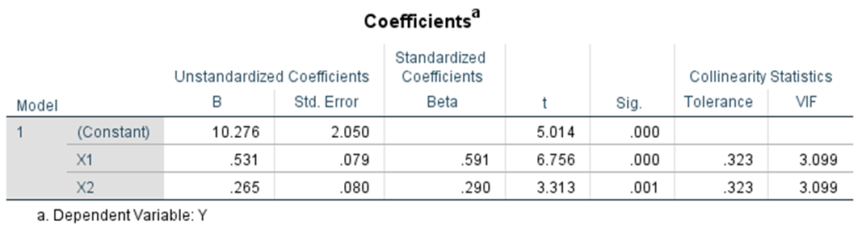
The result of multiple linear regression shows that Online Lectures (X1) and Online Discussion Participation (X2) variables have a significant influence on learning effectiveness (Y). The constant value of 10.276 indicates that without the contribution of variables X1 and X2, the average learning effectiveness is 10.276. Every one unit increase in Online Lectures (X1) will increase learning effectiveness by 0.531, while every one unit increase in Online Discussion Participation (X2) will increase learning effectiveness by 0.265, assuming other variables remain constant.
Based on the result of significance analysis, both independent variables have p-value < 0.05 (X1: 0.000 and X2: 0.001), which means both of them have significant effect on the dependent variable. In addition, the standardized beta coefficient analysis shows that the effect of Online Lectures on learning effectiveness is greater (Beta: 0.591) than Online Discussion Participation (Beta: 0.290).
Table 3. Test Coefficient of Determination (R2)
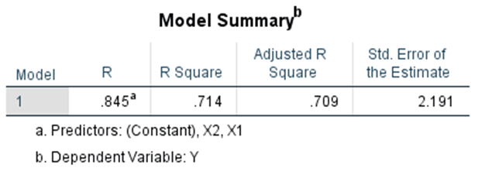
The Coefficient of Determination (R²) test is a technique in statistical analysis that serves to assess how much the independent variable is able to influence variations in the dependent variable. The R² value illustrates the percentage of the overall variation in the dependent variable that can be explained by the regression model used.

Based on the table above, it can be seen that the R Square is 0.714. R Square is used because the independent variable (X) > 1 variable. The coefficient of determination formula is KD = r2 × 100% = (0.714) × 100% = 71.4%. It can be concluded that Online Lectures (X1) and Online Discussion Participation (X2) simultaneously or together have an influence of 71.4% on students achievement together have an influence of 71.4% on the Learning EfEffectiveness of Office Administration Education at Jakarta State University students while the remaining 28.6% is influenced by other factors that doesn't examined by the researcher
5. Discussion
5.1 Online Lectures on Learning Effectiveness of Office Administration Education Students at Jakarta State University
This research aims to examine whether there is an influence between Online Lectures on the Learning Effectiveness in PAP students at FEB UNJ. The indicators used in this research are (1) Independence (2) Accessibility (3) Interactivity (4) Enrichment.
Researchers conducted an analysis requirement test namely normality test, heteroscedasticity test, and multicollinearity test. Based on the hypothesis using the t test which can be seen in Table 2. Parameter Regression Coefficient Test (t test) presented earlier, The statistical analysis shows that online lectures have a positive and significant effect on the Learning Effectiveness of Office Administration Education students at the Faculty of Economics & Business UNJ. This conclusion is supported by the Sig. value of 0.00, which is less than 0.05 (0.00 < 0.05). This statistical finding indicates that online lectures are truly beneficial for these students' educational outcomes.
The findings of this study align with Kuntarto (2017) research titled "The Effectiveness of Online Learning Models in Indonesian Language Lectures in Higher Education." Both studies demonstrate that online learning can positively impact the effectiveness of Indonesian Language courses at the university level. This research indicates that when online lectures are implemented to their full potential, they can successfully produce effective learning outcomes. Online education, when optimally designed and delivered, proves to be a valuable approach for achieving educational goals in higher education settings.
5.2 Online Discussion Participation on Learning Effectiveness of Office Administration Education Students at Jakarta State University
This research aims to examine whether there is an influence between Online Discussion Participation on the Learning Effectiveness in PAP students at FEB UNJ. The indicators used in this research are (1) Students Ability (2) Students Courage (3) Students Optimism to Express Their Opinions (4) Level of Collaboration With Other Participants.
Researchers conducted multiple linear regression tests namely the simultaneous regression coefficient test (F test), partial regression test (t test) and the coefficient of determination test (R2). Based on the research findings, the statistical analysis shows that students who actively participate in online discussions experience better learning outcomes in PAP FEB UNJ. This conclusion is supported by multiple statistical tests, particularly the t-test results shown in Tables 1, 2, and 3. The Sig. value of 0.00, which is less than the threshold of 0.05, provides strong statistical evidence that there is a genuine relationship between online discussion participation and learning effectiveness. The positive nature of this relationship means that higher levels of participation in online discussions correspond with improved learning outcomes for these students.
The results of this research are in line with research conducted by researcher Wulandini (2021) entitled "Effectiveness of Discussion Method in Online Learning in Improving Students' Social Studies Learning Outcomes" that research shows that active participation in discussions can improve student understanding through social interaction and collaboration, as well as providing constructive feedback. This means that Online Discussion Participation has a significant effect on learning effectiveness.
5.3 Online Lectures and Online Discussion Participation on Learning Effectiveness of Office Administration Education Students at Jakarta State University
This research aims to examine whether there is an influence between Online Lectures and Online Discussion Participation on Learning Effectiveness in PAP students at FEB UNJ. The indicators used include (1) Student Learning Outcomes, (2) Student Response to the Learning Process. (3) Teaching Evaluation, (4) Interaction between Teachers and Students, (5) Implementation of the Learning Process.
Researchers conducted multiple linear regression tests namely the simultaneous regression coefficient test (F test), partial regression test (t test) and the coefficient of determination test (R2). Based on the hypothesis using the t test which can be seen in Tables 1, 2, and 3, which were presented earlier, clearly show that Online Lectures and Online Discussion Participation have a positive and significant effect on the Learning Effectiveness of PAP FEB UNJ. This conclusion is supported by the significance (Sig.) value of 0.00, which is less than 0.05. This statistical result indicates that Online Lectures and student participation in Online Discussions contribute positively and significantly to the overall effectiveness of the learning process.
This research aligns with the study by Susanti (2021) titled *"The Effectiveness of Online Learning for Uhamka Economics Education Students During the COVID-19 Pandemic."* The study found that the effectiveness of online learning varied based on student participation levels. Around 72% of students considered online learning effective, as lecturers successfully implemented appropriate teaching methods. This indicates a positive impact of online learning and active participation in online discussions on overall learning effectiveness.
6. Conclusion, Implication, and Recommendation
Based on the comprehensive analysis conducted through methodical data processing and rigorous statistical testing procedures, the following conclusions can be definitively established:
- Empirical evidence derived from our methodical analysis demonstrates a statistically significant positive correlation between Online Lectures (X1) on Learning Effectiveness (Y) of Office Administration Education students, Faculty of Economics & Business at Jakarta State University.
- Empirical evidence derived from our methodical analysis demonstrates a statistically significant positive correlation between Online Discussion Participation (X2) on Learning Effectiveness (Y) of Office Administration Education students, Faculty of Economics & Business at Jakarta State University.
- Empirical evidence derived from our methodical analysis demonstrates a statistically significant positive correlation between Online Lectures (X1) and Online Discussion Participation (X2) on Learning Effectiveness (Y) of Office Administration Education students, Faculty of Economics & Business at Jakarta State University.
Based on the conclusions, implications, and limitations of the research that have been presented by previous researchers, these recommendations/suggestions for future researchers can be used as reference materials, evaluations, and references to deepen and obtain better research results. These recommendations include:
- Academic Suggestions:
- For lecturers, online discussion participation needs to be maintained and enhanced as it shows a significant positive influence on learning effectiveness. Lecturers should continue to facilitate interactive and engaging online discussions by implementing various methods such as small group discussions, case studies, or problem-based learning approaches. They can also utilize different online discussion formats like forums, live chat sessions, or virtual breakout rooms to maintain student engagement.
- For students, active participation in online learning can be increased as it is crucial for achieving optimal learning effectiveness. This can be addressed by institutions implementing student support programs that focus on developing digital literacy skills, time management in online learning environments, and effective online communication strategies. Additionally, institutions can provide technical support and resources to ensure students can fully participate in online learning activities without technical barriers.
- Practical Suggestions
For future researchers interested in studying online learning effectiveness, it is recommended to expand the research scope by involving respondents from various study programs or other faculties at Jakarta State University to obtain more comprehensive results. Future studies can also add other variables that may affect learning effectiveness, such as learning motivation, learning independence, or technological readiness. Additionally, further research can be conducted using a qualitative approach to gain deeper insights into students' experiences in online learning and online discussion participation. It would also be valuable to compare the effectiveness of learning between online, hybrid, and face-to-face learning methods to get a more complete picture. Moreover, researchers could examine more deeply the factors that influence student participation levels in online discussions and strategies to improve them. These expanded studies would contribute to a broader understanding of effective online learning implementation in higher education settings.
8. References
Alzahrani, G. M. (2017). The Effect of Using Online Discussion Forums on Students’ Learning. TOJET: The Turkish Online Journal of Educational Technology, 16(1), 164-165
Bao, W. (2020). COVID‐19 and online teaching in higher education: A case study of Peking University. Human Behavior and Emerging Technologies, 2(2), 113-115.
Dixson, M. D. (2015). Measuring student engagement in the online course: The Online Student Engagement scale (OSE). Online Learning, 19(4).
Ertmer, P. A., & Koehler, A. A. (2015). Facilitated versus non-facilitated online case discussions: comparing differences in problem space coverage. Journal of Computing in Higher Education, 27(2), 69–93. https://doi.org/10.1007/s12528-015-9094-5.
Ginanjar, Eggi. G, Bambang Darmawan, and Sriyono. (2019). Faktor-Faktor Yang Mempengaruhi Rendahnya Partisipasi Belajar Peserta Didik Smk. Journal of Mechanical Engineering Education, 6(2), 206–19.
Guiller, J., Durndell, A., & Ross, A. (2008). Peer interaction and critical thinking: Face-to-face or online discussion?. Advances in Economics and Business, 187–188, https://doi.org/10.1016/j.learninstruc.2007.03.001
Handarini, I., O., Wulandari, S., S. (2020). Pembelajaran Daring Sebagai Upaya Study From Home (SFH) Selama Pandemi Covid 19. Jurnal Pendidikan Administrasi Perkantoran (JPAP), 8(3), 496-499. https://journal.unesa.ac.id/index.php/jpap
Herawati, Retnowati. R., & Harijanto, S. (2021). Peningkatan Efektivitas Pembelajaran Melalui Penguatan Supervisi Akademik Dan Disiplin Kerja. Jurnal Manajemen Pendidikan, 9(1), 60–66.
Hidayah, F. A. A., Adawiyah, A. R., & Mahanani, R. A. P. (2020). Efektivitas Pembelajaran Daring di Masa Pandemi Covid-19. Sosial : Jurnal Penelitian Ilmu-Ilmu Sosial, 21(2), 54-55. https://doi.org/10.33319/sos.v21i2.61.
Indrijati, Herdina. (2017). Psikologi Perkembangan Dan Pendidikan Anak Usia Dini: Sebuah Bunga Rampai. Jakarta, Kencana.
Maki, R. H., Maki, W. S., Patterson, M., & Whittaker, P. D. (2000). Evaluation of a Web-based introductory psychology course: I. Learning and satisfaction in on-line versus lecture courses. Behavior Research Methods, Instruments, & Computers, 32(2), 230-239.
Means, B., Toyama, Y., Murphy, R., Bakia, M., & Jones, K. (2009). Evaluation of Evidence-Based Practices in Online Learning: A Meta-Analysis and Review of Online Learning Studies. US Department of Education.
Mislinawati, Fitriani, S. (2020). Tingkat Partisipasi Mahasiswa Dalam Perkuliahan Elearning Melalui Forum Diskusi Di Pgsd Fkip Unsyiah. Jurnal Pesona Dasar, 8(2), 36-38.
Nguyen, T. (2015) The Effectiveness of Online Learning: Beyond No Significant Difference and Future Horizons. MERLOT Journal of Online Learning and Teaching, 11(2), 309-310.
Nurjannah, Safiah, I., & Mislinawati. (2023), Perbandingan Hasil Belajar Siswa Dengan Model Pembelajaran Daring dan Luring Pada Mata Pelajaran IPA Tema 1 Subtema 1 PB 6 di Kelas 5 SDN 24 Banda Aceh. Jurnal Ilmiah Mahasiswa: Elementary Education Research, 8(3), 194–195.
Khusniyah, L. N. & Hakim, L. (2019). Efektifitas Pembelajaran Berbasis Daring: Sebuah Bukti pada Pembelajaran Bahasa Inggris. Jurnal Tatsqif: Jurnal Pemikiran dan Penelitian Pendidikan, 17(1), 19-20. https://doi.org/10.20414/jtq.v17i1.667.
Kirschner, P. A., Sweller, J., & Clark, R. E. (2006). Why minimal guidance during instruction does not work: An analysis of the failure of constructivist, discovery, problem-based, experiential, and inquiry-based teaching. Educational Psychologist, 41(2), 75-86.
Parsad, B., & Lewis, L. (2008). Distance Education at Degree-Granting Postsecondary Institutions: 2006-07. First Look. NCES 2009-044. National Center for Education Statistics.
Rahman, H., Mytra, P., Bahar, Yusuf, F., & Syamsuddin, F. A. (2023). Analisis Efektivitas Pembelajaran Virtual dalam Pembentukan Karakter Di Sekolah Dasar dan Perguruan Tinggi. Jurnal Pendidikan Dasar dan Keguruan, 8(1), 1-2. https://doi.org/10.47435/jpdk.v8i1.1883.
Rohmawati, A. (2015). Efektivitas Pembelajaran. Jurnal Pendidikan Usia Dini, 9(1), 17-18. https://doi.org/10.21009/JPUD.091.02.
Rusman. (2011). Pengembangan Berbasis Teknologi Informasi dan Komunikasi, Mengembangkan Profesionalitas Guru. Jakarta : PT. Raja Grafindo.
Sinar. (2018). Metode Active Learning. Jakarta, Deepublish.
Sofyana & Abdul. (2019). Pembelajaran Daring Kombinasi Berbasis Whatsapp Pada Kelas Karyawan Prodi Teknik Informatika Universitas PGRI Madiun. Jurnal Nasional Pendidikan Teknik Informatika, 8(1), 81-86.
Wahyuddin & Nurcahaya. (2019). Efektivitas Pembelajaran Matematika Melalui Pembelajaran Aktif Tipe Everyone Is a Teacher Here (ETH) Pada Siswa Kelas X Sma Negeri 8 Takalar. Al Khawarizmi: Jurnal Pendidikan dan Pembelajaran Matematika, 2(1), 72.

