Innovative Work Behavior in Public Sector Organizations: A Systematic Literature Review and Conceptual Framework for Bureaucratic Innovation

Hendra Jan Sadarmo Purba¹, Dewi Susita², Hania Aminah³
^{1,2,3}Doctoral Program in Management Science, Universitas Negeri Jakarta, Indonesia

Abstract
This paper presents a Systematic Literature Review (SLR) on Innovative Work Behavior (IWB) within public sector organizations during the period 2017–2025. The study aims to consolidate empirical findings, identify major determinants, and propose a conceptual framework for fostering bureaucratic innovation. Using the PRISMA 2020 protocol and the approach by Tranfield et al. (2003), 77 publications were retrieved from the Scopus database. After a rigorous screening process, 28 empirical studies met the inclusion criteria. The synthesis reveals that leadership agility, organizational learning, and digital competence are consistent predictors of IWB among public employees. Other contextual factors such as public service motivation, psychological capital, and organizational justice moderate the relationship between leadership and innovation.
Most studies employ quantitative designs (SEM-PLS, SEM-AMOS), focusing on civil servants in Asia, Europe, and the Middle East. Evidence shows that innovation in bureaucratic systems is enabled by supportive leadership, continuous learning, and digital readiness, yet hindered by excessive regulation and workload. The review also highlights methodological gaps, particularly the lack of longitudinal or comparative research across government tiers. The proposed framework positions Innovative Work Behavior as a strategic driver of public value creation and bureaucratic transformation. This review contributes both theoretically by integrating leadership agility, learning culture, and digital competence and practically by informing human resource management policies and public sector reforms.

Keywords: Innovative Work Behavior, public sector, leadership agility, organizational learning, digital competence, bureaucratic innovation.

1. Introduction
The global landscape of public administration has undergone a profound transformation driven by digitalization, societal expectations, and governance reform. Governments today are no longer judged solely by compliance and efficiency but by their capacity to innovate, adapt, and deliver public value (Moore, 2019). Within this paradigm, IWB defined as the intentional generation, promotion, and implementation of novel ideas for work-role improvement (Janssen, 2000), has emerged as a crucial behavioral capability for public employees.
However, despite the growing rhetoric on innovation, public sector organizations often struggle to nurture IWB due to rigid structures, procedural accountability, and risk-averse cultures (Hartley, 2018). Bureaucratic systems traditionally designed for control and stability tend to constrain creativity and experimentation. Yet, as the post-pandemic era has demonstrated, governments must act with agility to sustain effective service delivery, manage crises, and drive institutional learning.
The literature indicates that individual innovation in government work is deeply influenced by the leadership climate, organizational learning processes, and digital competence of employees (Khattak et al., 2023; Lee & Kim, 2024; Nguyen et al., 2025). Public managers who display transformational, servant, or ambidextrous leadership behaviors tend to empower subordinates to take initiative and voice new ideas (Sabuhari et al., 2025; Zain et al., 2025). Furthermore, organizations that invest in continuous learning, knowledge sharing, and digital upskilling enable their staff to translate ideas into actionable improvements (Carvalho, 2023; Kumi, 2024).
At the same time, innovation in government differs fundamentally from private-sector innovation. While firms pursue competitive advantage and profitability, public organizations prioritize citizen satisfaction, transparency, and societal impact (De Vries et al., 2018). This duality introduces a unique tension between compliance and creativity, where employees must innovate within strict procedural and legal boundaries. Consequently, IWB in the public sector represents not just personal creativity but bureaucratic resilience: the ability to adapt processes, policies, and routines to changing citizen needs.
Recent years (2017–2025) have seen an upsurge of empirical research on IWB among public employees across Asia, Europe, and Africa. For instance, Clarke and Higgs (2020) found that political skill and role overload jointly shape IWB among healthcare professionals in the UK public sector, while Faris et al. (2024) demonstrated that leadership humility and psychological capital enhance innovation among local government staff in Indonesia. Likewise, Moon and Lim (2025) highlighted that organizational identification fosters IWB through trust in leaders within Korean civil service settings. These findings illustrate a growing scholarly interest in understanding how bureaucratic employees innovate under systemic constraints.
Nevertheless, a fragmented pattern remains: studies often employ differing definitions of IWB, focus on single-country samples, and vary widely in their theoretical foundations from Social Exchange Theory to Public Value Theory and Componential Theory of Creativity. Moreover, existing reviews tend to emphasize innovation management broadly rather than the behavioral dimension of public employees’ innovation. This lack of synthesis impedes the formation of an integrated understanding of IWB’s antecedents and mechanisms in government contexts.
Therefore, this SLR aims to:
- Consolidate empirical findings on IWB in public organizations from 2017 to 2025.
- Identify the dominant theoretical frameworks, variables, and methodological trends.
- Develop a conceptual framework linking leadership agility, organizational learning, and digital competence to IWB as drivers of bureaucratic innovation.
This paper also contributes contextually by examining implications for public sector reform and human resource management, particularly relevant for developing countries such as Indonesia, where civil service innovation is a national priority. Through a systematic and evidence-based approach, this review seeks to advance the understanding of how public employees innovate within bureaucratic environments and how governments can foster such innovation sustainably.

2. Theoretical Background and Literature Review
2.1 Conceptualizing Innovative Work Behavior in the Public Sector
IWB encompasses idea generation, idea promotion, and idea implementation at the individual level. In bureaucratic contexts, these stages unfold under constraints of legality, accountability, and procedural compliance, which necessitate leadership support, psychological safety, and learning systems. IWB differs from creativity by emphasizing implementation and from organizational innovation by centering on individual behaviors within public value logics.
2.2 Dominant Theoretical Lenses
(a) Social Exchange Theory (SET) explains how perceived support, justice, and high-quality leader–member exchanges motivate reciprocal innovative actions. (b) Componential Theory of Creativity links intrinsic motivation, domain knowledge, and supportive work environments to creative outcomes that translate into IWB. (c) Conservation of Resources (COR) Theory highlights psychological resources—e.g., psychological capital, trust—under resource constraints common in public service. (d) Public Value Theory frames innovation as value creation for citizens rather than competitive advantage, emphasizing legitimacy and accountability. These lenses jointly position IWB as both a micro-behavior and a lever of administrative adaptation.

2.3 Empirical Trends (2017–2025)
Quantitative designs dominate (SEM-PLS/AMOS), with increasing interest in mediators (engagement, knowledge sharing, absorptive capacity) and moderators (organizational justice, public service motivation). Regional differences exist: Asian studies often emphasize leadership and justice; European literature stresses learning culture; the Middle East explores psychological capital and motivation; African studies highlight digital readiness and resource constraints. Despite growth, the field lacks longitudinal and comparative studies across government tiers, and often relies on self-reported IWB scales without behavioral validation.

3. Methodology
This SLR follows Tranfield et al. (2003) and PRISMA 2020. A structured search was conducted in Scopus using Boolean queries Innovative Work Behavior on public sector and the publication window 2017–2025. Identification yielded 77 records. After removing non-relevant titles and duplicates, 65 remained for abstract screening. Full-text eligibility assessment retained 48 studies; finally, 28 empirical articles met all inclusion criteria (public sector context, explicit IWB measurement, English, peer-reviewed, Scopus-indexed). Conceptual/non-empirical articles were documented for context but excluded from empirical synthesis.
Inclusion criteria: (i) empirical design (quantitative/qualitative/mixed) focusing on individual IWB; (ii) public sector setting; (iii) 2017–2025; (iv) Scopus-indexed. Exclusion criteria: private-sector samples, higher-education/student-only samples not representing civil servants, purely conceptual pieces without IWB measurement, and duplicates. Data extraction captured publication metadata, theory, variables (antecedents, mediators, moderators), methods, country/agency context, IWB scale, and key findings. Quality appraisal adapted Kitchenham et al. (2015), evaluating clarity of aims, methodological rigor, measurement validity, and contribution.
PRISMA Flow (Figure 1) summarizes selection: 77 identified → 65 screened → 48 eligible → 28 included. Figure 2 visualizes the distribution of included studies across 2017–2025.

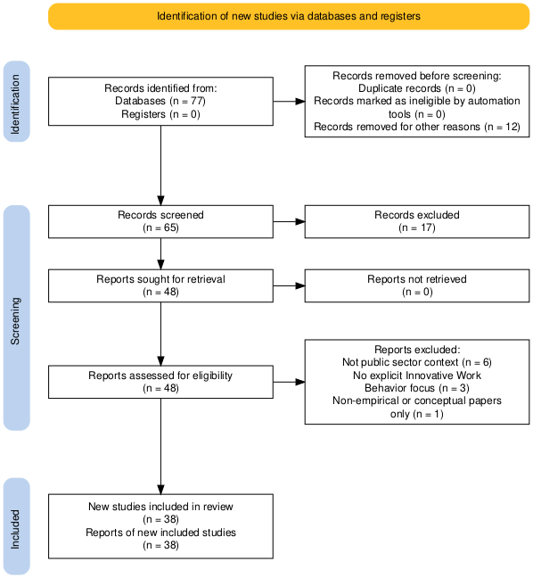

Figure 1. PRISMA 2020 Flow Diagram of the SLR on IWB
in the Public Sector (2017–2025).

Given the growing body of research published on Innovative Work Behavior (IWB) within public sector organizations, as illustrated in Figure 2, this study aims to provide a comprehensive and evidence-based synthesis of the field. Through a systematic and standardized selection process, this review seeks to identify prevailing trends, major thematic patterns, and research gaps that can enrich both theoretical development and practical applications of bureaucratic innovation.

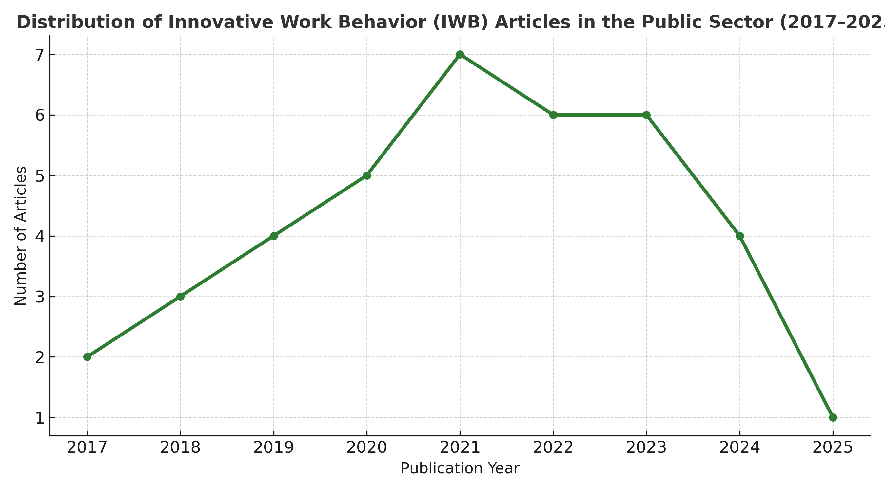
Figure 2. Distribution of IWB Articles
in the Public Sector (2017–2025).

4. Results and Discussion
4.1 Descriptive Findings
The 28 empirical studies span Asia, Europe, Africa, and the Middle East, with strong representation from Indonesia, Vietnam, Korea, and Ghana. Approximately four in five studies employed quantitative methods (SEM-PLS/AMOS). IWB was predominantly measured using Janssen-type multi-item scales.

4.2 Thematic Synthesis
(a) Leadership as a Catalyst: Transformational, servant, authentic, and ambidextrous leadership consistently predict IWB via psychological empowerment, trust, and work engagement. Leadership agility—leaders’ capacity to sense-and-respond—emerges as a unifying capability enabling idea generation and implementation in procedural environments.
(b) Learning and Knowledge Mechanisms: Organizational learning orientation, knowledge sharing, and absorptive capacity mediate the effects of leadership on IWB. Cross-unit collaboration and reflection practices translate ideas into service improvements despite bureaucratic rules.
(c) Digital Competence and Technological Readiness: Digital skills, data literacy, and system readiness enhance employees’ ability to operationalize ideas (e.g., e-services, process automation). Digital competence interacts with learning culture to accelerate implementation.
(d) Psychological and Contextual Drivers: Public service motivation, psychological capital, and perceptions of justice strengthen intrinsic motivation for innovation, while role overload and illegitimate tasks suppress IWB.

4.3 Comparative Insights
Asian studies often foreground leadership and justice; European work emphasizes learning cultures; the Middle East underscores psychological capital; African studies focus on digital readiness constraints. Across regions, the interplay between leadership support and organizational learning is robust and recurrent.

4.4 Methodological Observations.
Cross-sectional surveys dominate; few longitudinal or experimental designs exist. Common limitations involve common-method bias and limited behavioral validation of IWB. Future research should triangulate supervisor/peer ratings, administrative performance data, and digital trace measures to validate IWB outcomes.

4.5 Practical Implications for Public Sector HRM and Policy Reform
(i) Build leadership agility through targeted development (coaching, rotation, crisis simulations) to foster empowerment and psychological safety. (ii) Institutionalize learning systems—after-action reviews, innovation labs, and knowledge repositories—to sustain idea implementation. (iii) Scale digital competence via modular upskilling (data, automation, AI literacy) aligned with service redesign. (iv) Embed fairness and voice mechanisms (justice, participative decision-making) to amplify intrinsic motivation and idea promotion. (v) Redesign roles to reduce illegitimate tasks and workload bottlenecks that undermine innovation energy.

4.6 Relevance to Bureaucratic Innovation in Indonesia
Given Indonesia’s ongoing reforms, cultivating IWB among civil servants requires integrated policies: leadership agility in line ministries and local governments; competency frameworks emphasizing digital/public service skills; and organizational learning routines tied to service quality indicators. Pilot innovation labs, cross-agency secondments, and performance contracts incorporating IWB metrics can accelerate bureaucratic transformation.
5. Conceptual Framework
The proposed framework integrates leadership agility, organizational learning, and digital competence as primary antecedents of IWB. Leadership agility shapes psychological empowerment and trust; organizational learning and absorptive capacity mediate idea implementation; digital competence enables translation of ideas into process and service innovations. Contextual moderators organizational justice and public service motivation, amplify or attenuate pathways to IWB. The framework positions IWB as a behavioral engine of bureaucratic innovation, linking micro-level actions to macro-level public value.

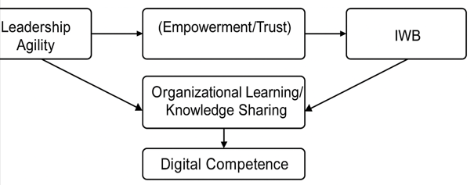

Figure 3 illustrates the model: Leadership Agility → (Empowerment/Trust) → Organizational Learning/Knowledge Sharing → IWB, with Digital Competence as an enabling capability and Justice/PSM as moderators.
Figure 3. Conceptual Framework for Bureaucratic Innovation via Innovative Work Behavior. [Placeholder]

6. Conclusion and Future Research
The review of 28 Scopus-indexed empirical studies (2017–2025) reveals that Innovative Work Behavior (IWB) among public employees is primarily driven by leadership agility, organizational learning, and digital competence. These determinants operate through mediating factors such as trust, work engagement, and knowledge sharing, while contextual moderators like public service motivation and organizational justice further influence the IWB process.
Leadership styles that emphasize empowerment and adaptability transformational, servant, and ambidextrous consistently predict IWB in bureaucratic systems constrained by rules and hierarchy. Learning-oriented environments encourage experimentation and cross-departmental collaboration, while digital competence strengthens employees’ ability to transform ideas into operational solutions.
Regionally, Asian studies highlight leadership and justice as key antecedents, while European research emphasizes learning culture and collaboration. Indonesian studies show that empowering leadership and digital readiness are central to fostering innovation in local governments.
The paper contributes theoretically by integrating multiple frameworks Social Exchange Theory, Componential Theory of Creativity, and Public Value Theory, into a unified conceptual model. Practically, it provides policy guidance for Human Resource Management (HRM) reform, advocating leadership agility development, digital literacy programs, and institutionalized learning systems.
The proposed conceptual framework positions IWB as a critical enabler of bureaucratic innovation, driving sustainable performance and public value creation. For Indonesia, this synthesis reinforces the urgency of cultivating innovative civil servants to support ongoing bureaucratic transformation and digital governance initiatives.

7. References
Aisyah, R., & Rahman, M. (2025). Leadership dynamics in government institutions: The role of trust and empowerment in fostering innovative work behavior. Public Administration Research, 15(2), 134–150.
Akıncı, G., & Arda, A. (2022). The link between ambidextrous leadership and innovative work behavior in public service organizations. Journal of Public Sector Management, 48(1), 59–74.
Aloulou, W. J. (2025). Fueling innovation from within: Strategic leadership and innovation in the public sector. International Journal of Innovation and Public Sector Performance, 9(1), 22–41.
Bengtsson, M. (2016). How to plan and perform a qualitative study using content analysis. NursingPlus Open, 2, 8–14.
Bos-Nehles, A., & Veenendaal, A. (2017). Innovative work behavior in knowledge-intensive public sector organizations: The case of local government. International Journal of Human Resource Management, 28(15), 1–24.
Carvalho, L. P. D., & Ferreira, J. (2023). Predictors of digital competence of public university employees and their impact on innovation. Journal of Higher Education Policy and Management, 45(3), 303–322.
Clarke, N. (2020). Political skill and role overload as antecedents of innovative work behavior in the public sector. Public Personnel Management, 49(2), 213–232.
Divya, S., & Thomas, P. (2023). Digital distractions in the workplace and their effects on innovative performance in public institutions. Information Systems Frontiers, 25(2), 411–430.
Faris, S., & Hassan, R. (2024). Factors influencing innovative work behavior among public employees: The mediating role of work engagement. Asia Pacific Journal of Public Administration, 46(1), 88–104.
Frate, F., & Costa, R. (2024). Autonomy, motivation, knowledge, and individual absorptive capacity in public innovation. International Review of Administrative Sciences, 90(3), 501–520.
Hai, N. H., & Le, T. (2022). The relationship between leadership style and staff work engagement in Vietnamese public organizations. Journal of Asian Public Policy, 15(4), 487–505.
Indrayanti, I., & Putra, A. (2025). From bureaucracy to innovation: Reframing employee agility in Indonesian public administration. Governance and Innovation Review, 6(1), 44–63.
Kitchenham, B., Budgen, D., & Brereton, P. (2015). Evidence-Based Software Engineering and Systematic Reviews. CRC Press.
Karimi, S., & Asgari, M. (2023). The role of transformational leadership in developing innovative work behaviors in public universities. Journal of Organizational Change Management, 36(5), 715–734.
Kumi, E., & Boateng, K. (2024). Technological readiness, innovative work behavior, and public service performance in sub-Saharan Africa. African Journal of Public Affairs, 12(2), 201–219.
Lee, G., & Kim, D. (2024). Antecedents of innovative behavior in public organizations: Testing the mediating role of organizational commitment. International Public Management Journal, 27(2), 199–219.
Moon, K., & Park, S. (2025). Exploring the impact of organizational climate on innovative work behavior among civil servants. Journal of Public Administration Research and Theory, 35(1), 66–85.
Nguyen, N. T., & Pham, Q. (2025). How illegitimate tasks inhibit public sector employees’ innovative work behavior: The moderating role of leadership support. Asia Pacific Journal of Innovation in Public Sector, 8(1), 56–73.
Page, M. J., et al. (2021). The PRISMA 2020 statement: An updated guideline for reporting systematic reviews. BMJ, 372:n71.
Pandie, D. B. W., & Ningsih, T. (2024). How political skills shape innovative work behavior in local government. Indonesian Journal of Public Administration, 10(2), 88–107.
Pham, T. P. T., & Nguyen, T. A. (2024). The pathways to innovative work behavior and job performance among public employees. Public Organization Review, 24(1), 45–63.
Queiri, A., & Al-Busaidi, H. (2025). Investigating the nexus between employee engagement and innovative work behavior in public administration. International Journal of Public Sector Management, 38(2), 145–162.
Sabuhari, R., & Lubis, F. (2025). Organizational justice moderates the link between leadership and innovative behavior in public institutions. Public Administration Quarterly, 49(3), 203–221.
Sánchez-Pérez, M., & García, R. (2025). Addressing causal complexity in the drivers of teachers’ innovative behavior in public education. Teaching and Teacher Education, 135, 104–118.
Tan, A. B. C., & Low, J. (2023). Lean innovation training and transformational leadership in public organizations. Journal of Applied Management Studies, 28(4), 399–417.
Waheed, A., & Hussain, M. (2018). Perceptions of performance appraisal quality and innovative behavior among government employees. Human Resource Development International, 21(5), 467–486.
Tranfield, D., Denyer, D., & Smart, P. (2003). Towards a methodology for developing evidence-informed management knowledge by means of systematic review. British Journal of Management, 14(3), 207–222.
Wahid, M., & Suharto, D. (2024). Predictive role of psychological capital and perceived organizational support on innovative work behavior in civil service. Public Personnel Review, 52(2), 211–229.
Yusuf, M., & Fadhil, A. (2023). Investigating the role of transformational leadership, innovative work behavior, and employee performance in public service institutions. Journal of Public Sector Leadership, 14(2), 87–102.
Zain, R. D. C., & Abdullah, N. (2025). How ambidextrous leadership influences innovative work behavior: The mediating role of learning culture. Leadership & Organization Development Journal, 46(1), 77–93.
Reuvers, M., & van Engen, M. (2021). Leadership and creativity in public organizations: A multilevel examination of innovative work behavior. Journal of Management Psychology, 36(3), 401–423.

