Open Access |  | Sentiment Analysis of the Policy on Reintroducing Academic Streaming in Senior High Schools Using the Random Forest Algorithm
E-ISSN: 2620 - 4872
Vol.09, No.01
Doi: 10.21009/JKOMA.091.02
 |  | Saire Fernando^{1*}, Mulyono², Ari Hendarno³, Ersa Resita⁴, Carli Apriansyah Hutagalung⁵
Recivied: 02June 2026
Accepted: 23 July 2026
Published: 31 July 2026
 |  | ^{1,2,3,4,5}Computer Science Study Program, Faculty of Mathematics and Natural Sciences, Universitas Negeri Jakarta, Jakarta, Indonesia.
Keywords:
Sentiment Analysis; |  | Abstract
Random Forestt; |  | In the 2025/2026 academic year, the Indonesian Ministry of Education, Culture, Research, and Technology proposed reinstating the academic streaming system in senior high schools. This policy quickly became the subject of public debate, generating diverse responses across social media platforms, particularly YouTube. This study aims to analyze public sentiment toward the policy using the Random Forest algorithm. The dataset was collected by scraping YouTube comments posted between April and June 2025, resulting in a total of 4,181 comments. The sentiment analysis revealed that public responses were predominantly neutral (76.7%), followed by positive (18.3%) and negative (5.0%) sentiments. The Random Forest model achieved an overall accuracy of 83.16%. In addition, the model obtained a precision of 77.56%, indicating that its sentiment predictions were relatively reliable. However, the recall score was 57.25%, suggesting that the model still encountered difficulties in identifying instances belonging to minority sentiment classes, particularly positive and negative sentiments. Overall, the model achieved an F1-score of 61.26%. The findings of this study are expected to provide valuable insights for policymakers, particularly the Ministry of Education, in evaluating public opinion and supporting evidence-based decision-making regarding the implementation or revision of educational policies.
Reinstatement of Academic Streaming;
YouTube Comments;
Education Policy.
*Correspondence Email:
Saire.fernando@yahoo.com

INTRODUCTION
The period from 2022 to 2025 has been marked by significant changes in Indonesia’s education system, particularly in the implementation of school curricula through the introduction of the Merdeka Curriculum by the Ministry of Education, Culture, Research, and Technology as an enhancement of the 2013 Curriculum to address post-pandemic educational challenges [1]. Also known as the prototype curriculum, the Merdeka Curriculum emphasizes flexible, student-centered, competency-based, and character-oriented learning. It was officially implemented in the 2022/2023 academic year, with one of its most notable changes being the elimination of the academic streaming system (Science, Social Sciences, and Language) at the beginning of senior high school education [2], [3].
The policy generated diverse responses from educators and parents, many of whom argued that the removal of academic streaming could create challenges in course scheduling and students’ preparation for higher education, where admission requirements often consider specific academic backgrounds [4]. Furthermore, several schools encountered implementation challenges due to limited facilities, shortages of teachers with interdisciplinary expertise, and varying levels of student readiness. These issues sparked public debate regarding the effectiveness of the policy in improving the quality of education [5], [6].
Based on these challenges, this study aims to address the existing research gap by analyzing public sentiment toward the policy to better understand the level of public acceptance. Accordingly, this research proposes a Random Forest-based sentiment analysis model to evaluate public opinions regarding the reinstatement of academic streaming in the senior high school curriculum. The findings are expected to provide valuable insights for educational policymakers in evaluating and refining future education policies based on public perceptions.

METHOD
This study consists of several stages in conducting sentiment analysis using the Random Forest algorithm. The overall research workflow is illustrated in the following flowchart:
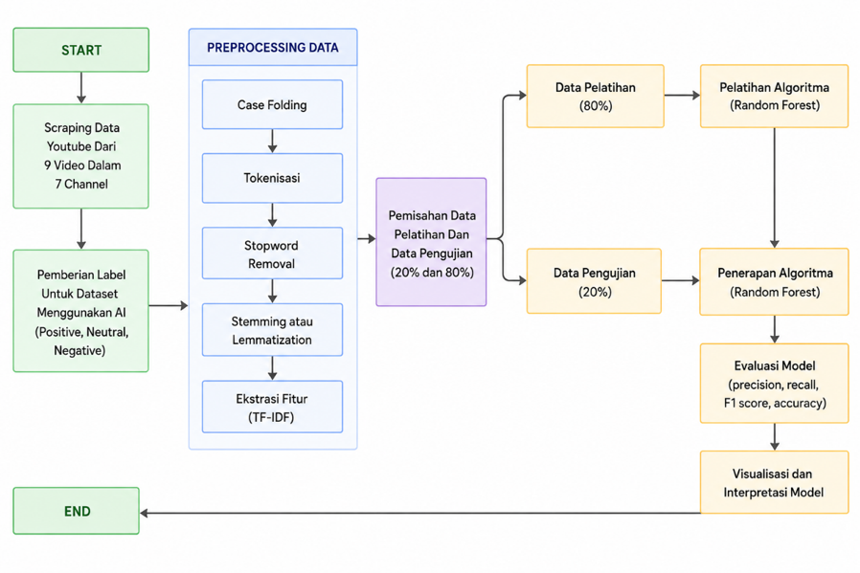
Figure 1. Sentiment Distribution

A. Data Collection
The study began with the collection of YouTube comments as the primary data source. Videos included in the dataset were required to have at least 100 comments, and the data collection period covered videos published between January 20, 2025, and August 20, 2025. To retrieve relevant data, several search keywords were used, including “Senior High School Academic Streaming Reinstatement”, “Policy on Reinstating Science, Social Science, and Language Streams”, and “Academic Streaming Will Be Reintroduced in Senior High Schools”. The data collection process was conducted using Google Cloud Console in conjunction with the YouTube Data API v3. This API provides access to publicly available data from YouTube, including videos, playlists, and channels. To utilize the API, a new project was first created in Google Cloud Console, followed by enabling the YouTube Data API v3 service. Subsequently, an API key was generated through the Credentials section and integrated into a Python program to retrieve the required data automatically. Finally, the collected data were exported and stored in CSV (.csv) format for subsequent preprocessing and sentiment analysis.

B. Data Labeling
The sentiment labeling process was performed entirely using Google Gemini AI, without manual intervention. This approach was adopted to ensure consistency in the labeling process and to eliminate potential subjective bias introduced by human annotators. In addition, the study aims to evaluate the capability of the Gemini AI model in automatically assigning sentiment labels to YouTube comments.

C. Data Preprocessing

After the sentiment labels were assigned, the dataset underwent a preprocessing stage to improve data quality before model training. The preprocessing process consisted of case folding, stopword removal, stemming (or lemmatization), and tokenization [7]. First, case folding was applied to convert all characters into lowercase, thereby ensuring text consistency and preventing the model from treating words with different letter cases as separate terms [8]. Subsequently, stopword removal was performed to eliminate common Indonesian words with limited semantic value, such as dan (“and”), yang (“which/that”), and itu (“that”) . Removing these words helps reduce noise in the dataset and enables the model to focus on more informative features [9]. Next, stemming or lemmatization was conducted to transform inflected or derived words into their root forms. For example, the Indonesian words jatuhkan and jatuhnya were normalized to the root word jatuh, reducing vocabulary size and improving textual consistency [10]. Finally, tokenization was carried out by splitting each document into individual tokens or words, which served as the basic units for feature extraction and subsequent sentiment classification using the Random Forest algorithm [11].

D. Data Splitting

After the TF-IDF feature extraction process was completed, the dataset was divided into training and testing subsets. In this study, the data partitioning strategy followed the approach adopted by Sidik, Sunarya, and Gunadi (2025) in their study entitled “Comparison of Random Forest and Support Vector Machine Methods in Sentiment Analysis of Student Satisfaction Questionnaire Comments at ITB STIKOM Bali.” Accordingly, 80% of the dataset was allocated for model training, while the remaining 20% was reserved for model testing [12]. This data partitioning strategy is widely adopted in machine learning studies to ensure that the model is trained on sufficient data while maintaining an independent dataset for performance evaluation.

E. Random Forest Classification and Model Evaluation

Following the preprocessing stage, the processed data were used to train a Random Forest classifier. The model was trained using 80% of the dataset and subsequently evaluated using the remaining 20% of unseen testing data. Model performance was assessed using a confusion matrix, from which several evaluation metrics were calculated, including accuracy, precision, recall, and F1-score. These metrics were employed to comprehensively evaluate the classification performance of the proposed model and its ability to correctly identify sentiment classes [13], [14].

F. Visualization and Interpretation

The final stage of the research workflow involved the visualization and interpretation of the classification results. After the Random Forest model achieved satisfactory performance, the sentiment analysis results were presented using graphical visualizations to facilitate interpretation. A pie chart was used to illustrate the distribution of public sentiment toward the policy on the reinstatement of academic streaming in senior high schools, showing the proportions of positive, negative, and neutral sentiments. In addition to percentage distributions, the visualization also presented the total number of comments belonging to each sentiment category, providing a clearer overview of public opinion regarding the proposed educational policy [15], [16].

RESULT AND DISCUSSION

A. Data Collection
This research began with the data collection process by gathering comments from YouTube. The data collection was conducted using the YouTube Data API v3, which can be accessed through the Google Cloud Console. The criteria for selecting videos required each video to contain a minimum of 100 comments, and the data collection process was conducted within the period from January 20, 2025, to August 20, 2025. Based on the search and collection process, the authors successfully obtained 9 videos with a total of 4,181 comments collected for further analysis.

Table 1. List of Collected Videos
Video Title | Channel Name | Number of Comments | Upload Date
Jurusan IPA, IPS dan Bahasa Akan Ada Lagi di SMA | Kompas.com | 154 | 12-04-25
Penjurusan IPA-IPS akan dihidupkan kembali, Pengamat; Kemunduran Dunia Pendidikan | SEDANG VIRAL | Liputan6 | 515 | 14-04-25
Wacana Penerapan kembali, masih relevan kah ? | Narasi Explains | Narasi Newsroom | 183 | 19-04-25
[FULL] Mendikdasmen Akan Hidupkan Lagi Jurusan IPA< IPS, Bahasa di SMA, Begini Respon Orang Tua | KOMPAS TV | 284 | 20-04-25
Jurusan IPA, IPS dan Bahasa Akan Ada Lagi di SMA | Kompas.com | 174 | 12-04-25
Ganti Kurikulum lagi ? IPA IPS balik lagi nih ? #shot | Gerald Vincent | 1974 | 17-04-25
Menteri Abdul Mukti Kembalikan Sistem Penjurusan IPA-IPS-Bahasa di SMA, Tuai Pro dan Kontra | Millenialzkece | 438 | 13-04-25
[FULL] Dialog-Urgensi Kembalinya Penjurusan di SMA- [Metro Siang] | Metro TV | 128 | 16-04-25

The table above presents several YouTube videos discussing the plan to reinstate the Science (IPA), Social Sciences (IPS), and Language (Bahasa) specialization system in senior high schools. These videos were uploaded by various news channels and content creators in April 2025. Based on the number of comments, this topic received considerable attention from the public. The video uploaded by Gerald Vincent received the highest number of comments, with 1,974 comments, while the video from Liputan6 received 515 comments. This indicates that the issue of high school specialization has become a widely discussed topic and has generated various opinions, including both support and opposition, among the public.

Table 2. List of Collected Comments
No | Comments
1 | Kalo nilai IPA tinggi yg jurusan IPA dst. Gitu aja ga beres2 puluhan tahun. Gimana mau benahi guru dan bukunya.
2 | Ilmu sudah berkembang begitu jauh. Malah main copy negara maju seperti Finlandia. Bodohnya ga karuan
3 | Walupun sekolah tinggi, tidak ada sistem yang bagus. Yang ada sistem yang cocok dengan tempatnya
4 | Mohon pak kami tidak mau lahi jadi bahan percobaan tolongggg
5 | Setuju balikin lagi, daripada sistem tukang ojek ga jelas merusak tatanan pendidikan
6 | Tolonglah indonesia
7 | Pendidikan Moral Pancasila
8 | Perlu dihidupkan kembali pelajaran itu, spy attitude generasi muda lebih baik lagi

The table above presents several public comments regarding the plan to reinstate the Science (IPA), Social Sciences (IPS), and Language (Bahasa) specialization system in senior high schools. Most of the comments expressed support for the policy, as it was considered more suitable for students’ abilities and interests. Some comments also highlighted the importance of improving the education system, enhancing teacher quality, and strengthening character and moral education. In addition, several comments opposed frequent curriculum changes because they were considered to create inconsistency in the education system. Overall, the table indicates that the public has significant concerns regarding education policies and hopes that the implemented system can provide better outcomes for future generations.

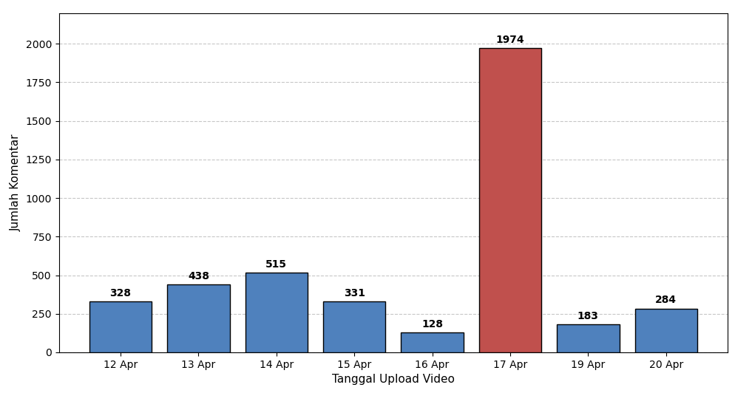
Figure 1. Distribution of Collected Comments

Although the data collection process was conducted during the period from January 20, 2025, to August 20, 2025, the successfully collected data were only obtained in April 2025. As shown in “FIGURE 3”, the highest increase in discussion activity occurred on April 17, 2025, contributing 1,974 comments from a single educational YouTube Shorts video uploaded by Gerald Vincent entitled “Ganti kurikulum lagi? IPA IPS balik lagi nih? #shorts”.

B. Data Labeling
With a total of 4,181 collected comments, the data labeling process was conducted to prepare the dataset for the training and testing stages of the algorithm. The entire labeling process was performed using Artificial Intelligence (AI), without any human intervention. This approach was applied to minimize inconsistency in the labeling process and to evaluate the capability of Google Gemini AI in performing sentiment annotation.

Table 3. Example of LLM-Based Sentiment Labeling Results
Comments | LLM Sentiment
Kalo nilai IPA tinggi yg jurusan IPA dst. Gitu aja ga beres2 puluhan tahun. Gimana mau benahi guru dan bukunya. | Negatif
Ilmu sudah berkembang begitu jauh. Malah main copy negara maju seperti Finlandia. Bodohnya ga karuan | Negatif
Walupun sekolah tinggi, tidak ada sistem yang bagus. Yang ada sistem yang cocok dengan tempatnya | Negatif
Mohon pak kami tidak mau lahi jadi bahan percobaan tolongggg | Netral
Setuju balikin lagi, daripada sistem tukang ojek ga jelas merusak tatanan pendidikan | Negatif
Tolonglah indonesia | Netral
Pendidikan Moral Pancasila | Netral
Perlu dihidupkan kembali pelajaran itu, spy attitude generasi muda lebih baik lagi | Positif
Sebaiknya jurusan di SMA cukup 2 jurusan saja yaitu IPA dan Jurusan IPS | Positif

The total dataset obtained from the labeling process consisted of 2,685 neutral comments, 825 negative comments, and 671 positive comments. The distribution of sentiment classes was 64.2% neutral, 19.7% negative, and 16.0% positive, from a total of 4,181 comments. This distribution indicates that the majority of public responses toward the discussed policy were categorized as neutral, while negative and positive sentiments represented smaller proportions of the dataset.

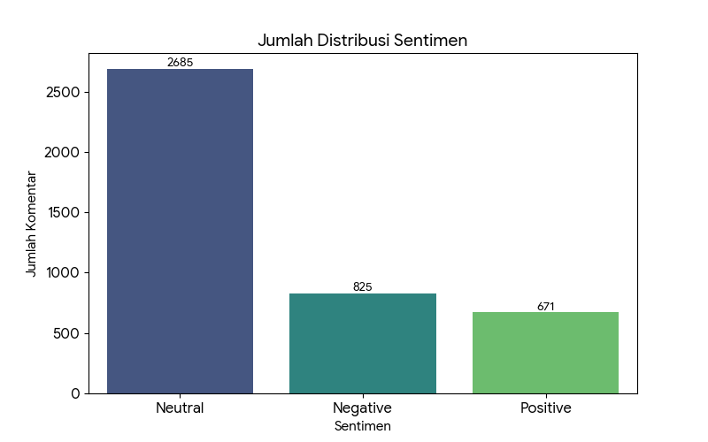
Figure 5. AI-Based Sentiment Distribution Statistics

The figure above illustrates the distribution of public sentiment regarding the issue of reinstating the Science (IPA), Social Sciences (IPS), and Language (Bahasa) specialization system in senior high schools. The sentiment classification consists of three categories: neutral, negative, and positive. Based on the visualization, the neutral sentiment category dominates with a total of 2,685 comments. This indicates that most of the public responses were informative, expressed general opinions, or did not explicitly support or oppose the proposed policy.
Meanwhile, the negative sentiment category accounted for 825 comments, which was higher than the positive sentiment category with 671 comments. This condition indicates that a considerable number of people expressed disagreement, concerns, or doubts regarding the reinstatement of the specialization system in senior high schools. Nevertheless, positive comments were also identified, with several respondents supporting the policy because it was considered capable of helping students focus on their interests and abilities..

C. Data Preprocessing
After the data labeling process was completed, the dataset underwent a preprocessing stage. The preprocessing steps consisted of case folding, tokenization, stopword removal, and stemming or lemmatization. These processes were performed to transform the raw text data into a cleaner and more structured format, enabling the Random Forest algorithm to process the data more effectively and efficiently during the classification stage.

Case Folding
Table 4. Case Folding Results
Original Comment | Case Folding Result
Kalo nilai IPA tinggi yg jurusan IPA dst. Gitu aja ga beres2 puluhan tahun. Gimana mau benahi guru dan bukunya. Ilmu sudah berkembang begitu jauh. Malah main copy negara maju seperti Finlandia. Bodohnya ga karuan walaupun sekolah tinggi. Tidak ada sistem yg paling bagus, yg ada sistem yg cocok dgn tempatnya. Mau sistem Finlandia atau Singapura sama aja kalo guru dan bukunya tidak siap. | kalo nilai ipa tinggi yg jurusan ipa dst. gitu aja ga beres2 puluhan tahun. gimana mau benahi guru dan bukunya. ilmu sudah berkembang begitu jauh. malah main copy negara maju seperti finlandia. bodohnya ga karuan walaupun sekolah tinggi. tidak ada sistem yg paling bagus, yg ada sistem yg cocok dgn tempatnya. mau sistem finlandia atau singapura sama aja kalo guru dan bukunya tidak siap.
Mohon pak kami tidak mau lagi jadi bahan percobaan tolonggg | mohon pak kami tidak mau lagi jadi bahan percobaan tolonggg
Pendidikan Moral Pancasila  Perlu dihidupkan kembali pelajaran itu, spy attitude generasi muda lebih baik lg | pendidikan moral pancasila  perlu dihidupkan kembali pelajaran itu, spy attitude generasi muda lebih baik lg

Stopword Removal
Table 5. Stopword Removal Results
Original Comment | Case Folding Result
kalo nilai ipa tinggi yg jurusan ipa dst. gitu aja ga beres2 puluhan tahun. gimana mau benahi guru dan bukunya. ilmu sudah berkembang begitu jauh. malah main copy negara maju seperti finlandia. bodohnya ga karuan walaupun sekolah tinggi. tidak ada sistem yg paling bagus, yg ada sistem yg cocok dgn tempatnya. mau sistem finlandia atau singapura sama aja kalo guru dan bukunya tidak siap. | kalo nilai ipa tinggi yg jurusan ipa dst. gitu aja ga beres2 puluhan tahun. gimana mau benahi guru bukunya. ilmu berkembang jauh. malah main copy negara maju finlandia. bodohnya ga karuan walaupun sekolah tinggi. sistem yg paling bagus, yg ada sistem yg cocok dgn tempatnya. mau sistem finlandia singapura sama aja kalo guru bukunya tidak siap.
mohon pak kami tidak mau lagi jadi bahan percobaan tolonggg | mohon pak tidak mau jadi bahan percobaan tolonggg
pendidikan moral pancasila  perlu dihidupkan kembali pelajaran itu, spy attitude generasi muda lebih baik lg | pendidikan moral pancasila perlu dihidupkan pelajaran, spy attitude generasi muda lebih baik

Stemming Or Lemmatization
Table 6. Stemming Or Lemmatization Results
Original Comment | Case Folding Result
kalo nilai ipa tinggi yg jurusan ipa dst. gitu aja ga beres2 puluhan tahun. gimana mau benahi guru bukunya. ilmu berkembang jauh. malah main copy negara maju finlandia. bodohnya ga karuan walaupun sekolah tinggi. sistem yg paling bagus, yg ada sistem yg cocok dgn tempatnya. mau sistem finlandia singapura sama aja kalo guru bukunya tidak siap. | kalo nilai ipa tinggi yg jurus ipa dst gitu aja ga beres2 puluh tahun gimana mau benah guru buku ilmu kembang jauh malah main copy negara maju finlandia bodoh ga karuan walaupun sekolah tinggi sistem yg paling bagus yg ada sistem yg cocok dgn tempat mau sistem finlandia singapura sama aja kalo guru buku tidak siap
mohon pak tidak mau jadi bahan percobaan tolonggg | mohon pak tidak mau jadi bahan coba tolonggg
pendidikan moral pancasila perlu dihidupkan pelajaran, spy attitude generasi muda lebih baik | didik moral pancasila perlu hidup ajar spy attitude generasi muda lebih baik

Tokenization
Table 7. Tokenization Results
Original Comment | Case Folding Result
kalo nilai ipa tinggi yg jurus ipa dst gitu aja ga beres2 puluh tahun gimana mau benah guru buku ilmu kembang jauh malah main copy negara maju finlandia bodoh ga karuan walaupun sekolah tinggi sistem yg paling bagus yg ada sistem yg cocok dgn tempat mau sistem finlandia singapura sama aja kalo guru buku tidak siap | ['kalo', 'nilai', 'ipa', 'tinggi', 'yg', 'jurus', 'ipa', 'dst', 'gitu', 'aja', 'ga', 'beres2', 'puluh', 'tahun', 'gimana', 'mau', 'benah', 'guru', 'buku', 'ilmu', 'kembang', 'jauh', 'malah', 'main', 'copy', 'negara', 'maju', 'finlandia', 'bodoh', 'ga', 'karuan', 'walaupun', 'sekolah', 'tinggi', 'sistem', 'yg', 'paling', 'bagus', 'yg', 'ada', 'sistem', 'yg', 'cocok', 'dgn', 'tempat', 'mau', 'sistem', 'finlandia', 'singapura', 'sama', 'aja', 'kalo', 'guru', 'buku', 'tidak', 'siap']
mohon pak tidak mau jadi bahan coba tolonggg | ['mohon', 'pak', 'tidak', 'mau', 'jadi', 'bahan', 'coba', 'tolonggg']
didik moral pancasila perlu hidup ajar spy attitude generasi muda lebih baik | ['didik', 'moral', 'pancasila', 'perlu', 'hidup', 'ajar', 'itu', 'spy', 'attitude', 'generasi', 'muda', 'lebih', 'baik']

D. TF - IDF
After completing the data labeling and preprocessing stages, the dataset was transformed into numerical representations using TF-IDF (Term Frequency–Inverse Document Frequency). This transformation was required because the Random Forest algorithm cannot directly process textual data, therefore each comment was converted into numerical feature vectors before the classification process.
The TF-IDF calculation was implemented through three main processes: Term Frequency (TF), Inverse Document Frequency (IDF), and TF-IDF computation. The TF calculation measures the frequency of a word appearing within an individual document, while the IDF calculation determines the importance of a word based on its occurrence across the entire document collection. Words that frequently appear in many documents receive lower weights, whereas rare words receive higher weights. The final TF-IDF value is obtained by combining TF and IDF scores, producing numerical representations of each comment.
In this study, the TF-IDF process generated a vocabulary from the preprocessed comments and converted each comment into a numerical vector based on the occurrence and importance of each word. For example, a document containing the words “bagus”, “buku”, and “ini” will be represented as a vector according to their TF-IDF values. The generated vectors were then used as input features for the Random Forest classifier to perform sentiment classification.

Table 8. Tabel Vektor TF-IDF
Vocabulary | TF | IDF (Ilustrasi) | TF-IDF
‘bagus’ | 1/3 = 0.33 | 1.2 | 0.396
‘buku’ | 1/3 = 0.33 | 1 | 0.33
‘ini’ | 1/3 = 0.33 | 1.2 | 0.396

The resulting TF-IDF vector representation from the example above is [0.396, 0.330, 0.396, 0.0, 0.0, 0.0]. These numerical vectors become the input features for the Random Forest model. The classifier then constructs multiple decision trees and combines their outputs through the ensemble learning mechanism to determine the final sentiment category of each comment.

E. Data Splitting
After completing the TF-IDF word embedding process, the dataset was divided into training and testing data. In this study, the data splitting strategy followed the approach used in the study entitled “Comparison of Random Forest and Support Vector Machine Methods in Sentiment Analysis of Student Satisfaction Questionnaire Comments at ITB STIKOM Bali” by Purnama Sidik, I Made Gede Sunarya, and I Gede Aris Gunadi (2025). The dataset was divided using an 80:20 ratio, where 80% of the data was used for training and 20% was used for testing. Based on the total of 4,181 comments, the dataset was divided into 3,344 training data and 837 testing data. The training data were used to build the Random Forest model, while the testing data were used to evaluate the model performance.

F. Klasifikasi dengan Algoritma Random Forest
After the TF-IDF transformation process, the generated feature vectors were classified using the Random Forest algorithm. Random Forest was selected because it is an ensemble learning algorithm that combines multiple decision trees to improve classification stability.
In this study, the Random Forest model was implemented by constructing multiple decision trees using TF-IDF features as input. Each decision tree determines splitting criteria using Gini Impurity and Information Gain to identify the most relevant features for sentiment classification. The diversity of trees was generated through the bagging mechanism, where each tree was trained using randomly selected subsets of training data.
The model parameters used in this research were n_trees = 5, max_depth = 5, and sample_size = 0.8. During the training process, each tree learned sentiment patterns from the TF-IDF representations and labeled comments. During prediction, new comments were converted into TF-IDF vectors and processed by all decision trees. The final sentiment category was determined using majority voting from all generated tree predictions.

TABEL 9. Tabel Pohon dan Hutan
Contoh Hutan
Tree 1 | Negative
Tree 2 | Negative
Tree 3 | Negative
Tree | Negative
Tree 5 | Negative
Final Prediction : Negative

G. Evaluasi Random Forest dan Analisis Sentimen
The evaluation process was conducted to measure the performance of the trained Random Forest model in classifying sentiment categories. The model performance was evaluated using a confusion matrix, which was used to calculate the classification metrics, including precision, recall, and F1-score. In addition, the evaluation results were visualized using bar charts and pie charts to provide a clearer interpretation of sentiment classification performance and distribution. Based on the evaluation results, the negative sentiment classification achieved a precision of 97%, recall of 87%, and F1-score of 91%. The neutral sentiment classification obtained a precision of 96%, recall of 99%, and F1-score of 97%. Meanwhile, the positive sentiment classification achieved a precision of 90%, recall of 91%, and F1-score of 91%.
Overall, the Random Forest model achieved an accuracy of 95.22%, with an overall precision of 94.34%, recall of 92.34%, and F1-score of 93%. These results indicate that the developed model was able to classify public sentiment regarding the reinstatement policy of academic specialization in senior high schools with high performance..

Table 10. Random Forest Sentiment Analysis Classification Report
 | Precision | Recall | F1-Score
Negative | 0.97 | 0.87 | 0.91
Neutral | 0.96 | 0.99 | 0.97
Positive | 0.90 | 0.91 | 0.91

Table 11. Random Forest Sentiment Analysis Confusion Matrix Results
True / Prediction | Negative | Neutral | Positive
Negative | 143 | 11 | 11
Neutral | 4 | 532 | 2
Positive | 1 | 11 | 122

The Random Forest model was trained using 3,344 labeled comments and evaluated using 837 testing comments. The evaluation results showed that the model classified 538 comments as neutral sentiment, 165 comments as negative sentiment, and 134 comments as positive sentiment. These results indicate that the model was able to identify sentiment patterns from public comments related to the policy with consistent classification performance.
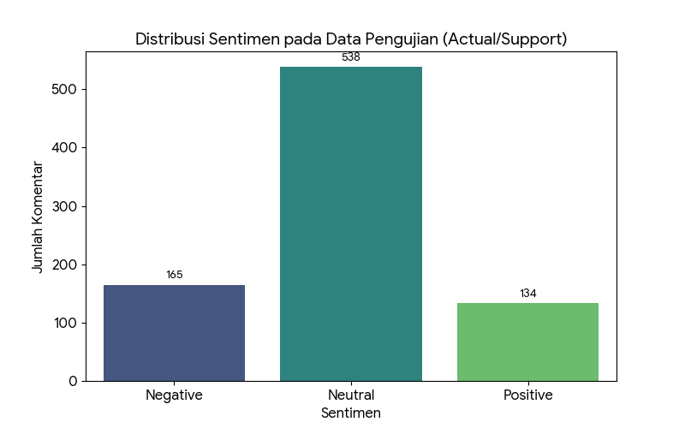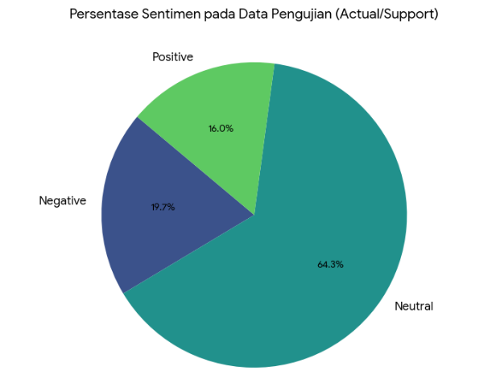
Figure 6. Sentiment Category Distribution Figure 7. Sentiment Distribution Percentage

The sentiment distribution analysis revealed that YouTube comments discussing the policy of reinstating academic specialization in the high school curriculum were dominated by neutral responses (64.3%). Furthermore, negative sentiments (19.7%) outnumbered positive sentiments (16%), indicating a relatively more critical public response toward the policy.

CONCLUSION
This study successfully developed a sentiment analysis model using the Random Forest algorithm to identify public opinions regarding the policy of reinstating academic specialization in the senior high school curriculum based on YouTube comments. A total of 4,181 comments were collected using the YouTube Data API v3 and processed through several stages, including text preprocessing, TF-IDF feature extraction, and Random Forest classification.
The sentiment analysis results showed that public responses were predominantly categorized as neutral, with 2,685 comments (64.3%), followed by negative sentiment with 825 comments (19.7%) and positive sentiment with 671 comments (16.0%). These findings indicate that most users expressed general opinions or informational responses, while among the explicit opinions, negative responses were slightly higher than positive responses toward the policy.
The developed Random Forest model achieved an accuracy of 95.22%, with precision of 94.34%, recall of 92.34%, and an F1-score of 93%. These results demonstrate that the model was able to classify sentiment categories effectively. However, the evaluation also revealed that the dataset distribution was imbalanced, where neutral comments dominated the dataset. Therefore, model evaluation should consider additional metrics such as macro-average evaluation to provide a more comprehensive assessment of classification performance.
Despite achieving good classification performance, this study has several limitations, particularly regarding automated sentiment labeling using Gemini AI, which may still encounter difficulties in interpreting sarcasm, implicit expressions, and contextual meanings. Future research may improve the labeling process through human validation and expand data collection from other social media platforms, such as Twitter/X and Facebook, to obtain a broader representation of public opinion toward education policies.

REFERENCE
[1] W. Ndari, Suyatno, Sukirman, and F. N. Mahmudah, “Implementation of the Merdeka Curriculum and Its Challenges,” European Journal of Education and Pedagogy, vol. 4, no. 3, pp. 111–116, Jun. 2023, doi: 10.24018/ejedu.2023.4.3.648.
[2] W. L. Rahmadani and D. Mustika, “The Revealing the Practice of the Merdeka Belajar Curriculum: Implementation in Elementary Schools,” QALAMUNA: Jurnal Pendidikan, Sosial, dan Agama, vol. 15, no. 1, pp. 599–616, Jun. 2023, doi: 10.37680/qalamuna.v15i1.4144.
[3] C. Azmi, H. Hadiyanto, and R. Rusdinal, “National Curriculum Education Policy ‘Curriculum Merdeka And Its Implementation,’” International Journal of Educational Dynamics, vol. 6, no. 1, pp. 303–309, Dec. 2023, doi: 10.24036/ijeds.v6i1.437.
[4] S. Ben Gurion and N. Nasir, “Teacher Readiness in Implementing ‘the Merdeka Curriculum,’” Journal of Education and Teaching (JET), vol. 5, no. 1, pp. 108–118, Jun. 2024, doi: 10.51454/jet.v5i1.321.
[5] D. Yunitasari, I. W. Suastra, and I. W. Lasmawan, “Implementation challenges of merdeka curriculum in primary schools,” Prisma Sains : Jurnal Pengkajian Ilmu dan Pembelajaran Matematika dan IPA IKIP Mataram, vol. 11, no. 4, p. 952, Aug. 2023, doi: 10.33394/j-ps.v11i4.8079.
[6] K. P. S. Dirgantoro and R. H. Soesanto, “Towards a Paradigm Shift: Analysis of Student Teachers’ and Teacher Education Institutions’ Readiness on Kurikulum Merdeka,” Jurnal Pendidikan dan Kebudayaan, vol. 8, no. 2, pp. 185–201, Dec. 2023, doi: 10.24832/jpnk.v8i2.4271.
[7] J. R. Jim, M. A. R. Talukder, P. Malakar, M. M. Kabir, K. Nur, and M. F. Mridha, “Recent advancements and challenges of NLP-based sentiment analysis: A state-of-the-art review,” Natural Language Processing Journal, vol. 6, p. 100059, Mar. 2024, doi: 10.1016/j.nlp.2024.100059.
[8] M. A. Palomino and F. Aider, “Evaluating the Effectiveness of Text Pre-Processing in Sentiment Analysis,” Applied Sciences, vol. 12, no. 17, p. 8765, Aug. 2022, doi: 10.3390/app12178765.
[9] Y. Mao, Q. Liu, and Y. Zhang, “Sentiment analysis methods, applications, and challenges: A systematic literature review,” Journal of King Saud University - Computer and Information Sciences, vol. 36, no. 4, p. 102048, Apr. 2024, doi: 10.1016/j.jksuci.2024.102048.
[10] K. L. Tan, C. P. Lee, and K. M. Lim, “A Survey of Sentiment Analysis: Approaches, Datasets, and Future Research,” Applied Sciences, vol. 13, no. 7, p. 4550, Apr. 2023, doi: 10.3390/app13074550.
[11] C. P. Chai, “Comparison of text preprocessing methods,” Nat. Lang. Eng., vol. 29, no. 3, pp. 509–553, May 2023, doi: 10.1017/S1351324922000213.
[12] P. Sidik, I Made Gede Sunarya, and I Gede Aris Gunadi, “Comparison of Random Forest and Support Vector Machine Methods in Sentiment Analysis of Student Satisfaction Questionnaire Comments at ITB STIKOM Bali,” Journal of Applied Informatics and Computing, vol. 9, no. 3, pp. 794–802, Jun. 2025, doi: 10.30871/jaic.v9i3.9617.
[13] Y. Mao, Q. Liu, and Y. Zhang, “Sentiment analysis methods, applications, and challenges: A systematic literature review,” Journal of King Saud University - Computer and Information Sciences, vol. 36, no. 4, p. 102048, Apr. 2024, doi: 10.1016/j.jksuci.2024.102048.
[14] J. R. Jim, M. A. R. Talukder, P. Malakar, M. M. Kabir, K. Nur, and M. F. Mridha, “Recent advancements and challenges of NLP-based sentiment analysis: A state-of-the-art review,” Natural Language Processing Journal, vol. 6, p. 100059, Mar. 2024, doi: 10.1016/j.nlp.2024.100059.
[15] D. Dangi, D. K. Dixit, and A. Bhagat, “Sentiment analysis of COVID-19 social media data through machine learning,” Multimed. Tools Appl., vol. 81, no. 29, pp. 42261–42283, Dec. 2022, doi: 10.1007/s11042-022-13492-w.
[16] T. A. U. Azmi, L. Hakim, D. C. R. Novitasari, and W. D. U. D. Utami, “Application Random Forest Method for Sentiment Analysis in Jamsostek Mobile Review,” Telematika, vol. 20, no. 1, p. 117, Mar. 2023, doi: 10.31315/telematika.v20i1.8868.

